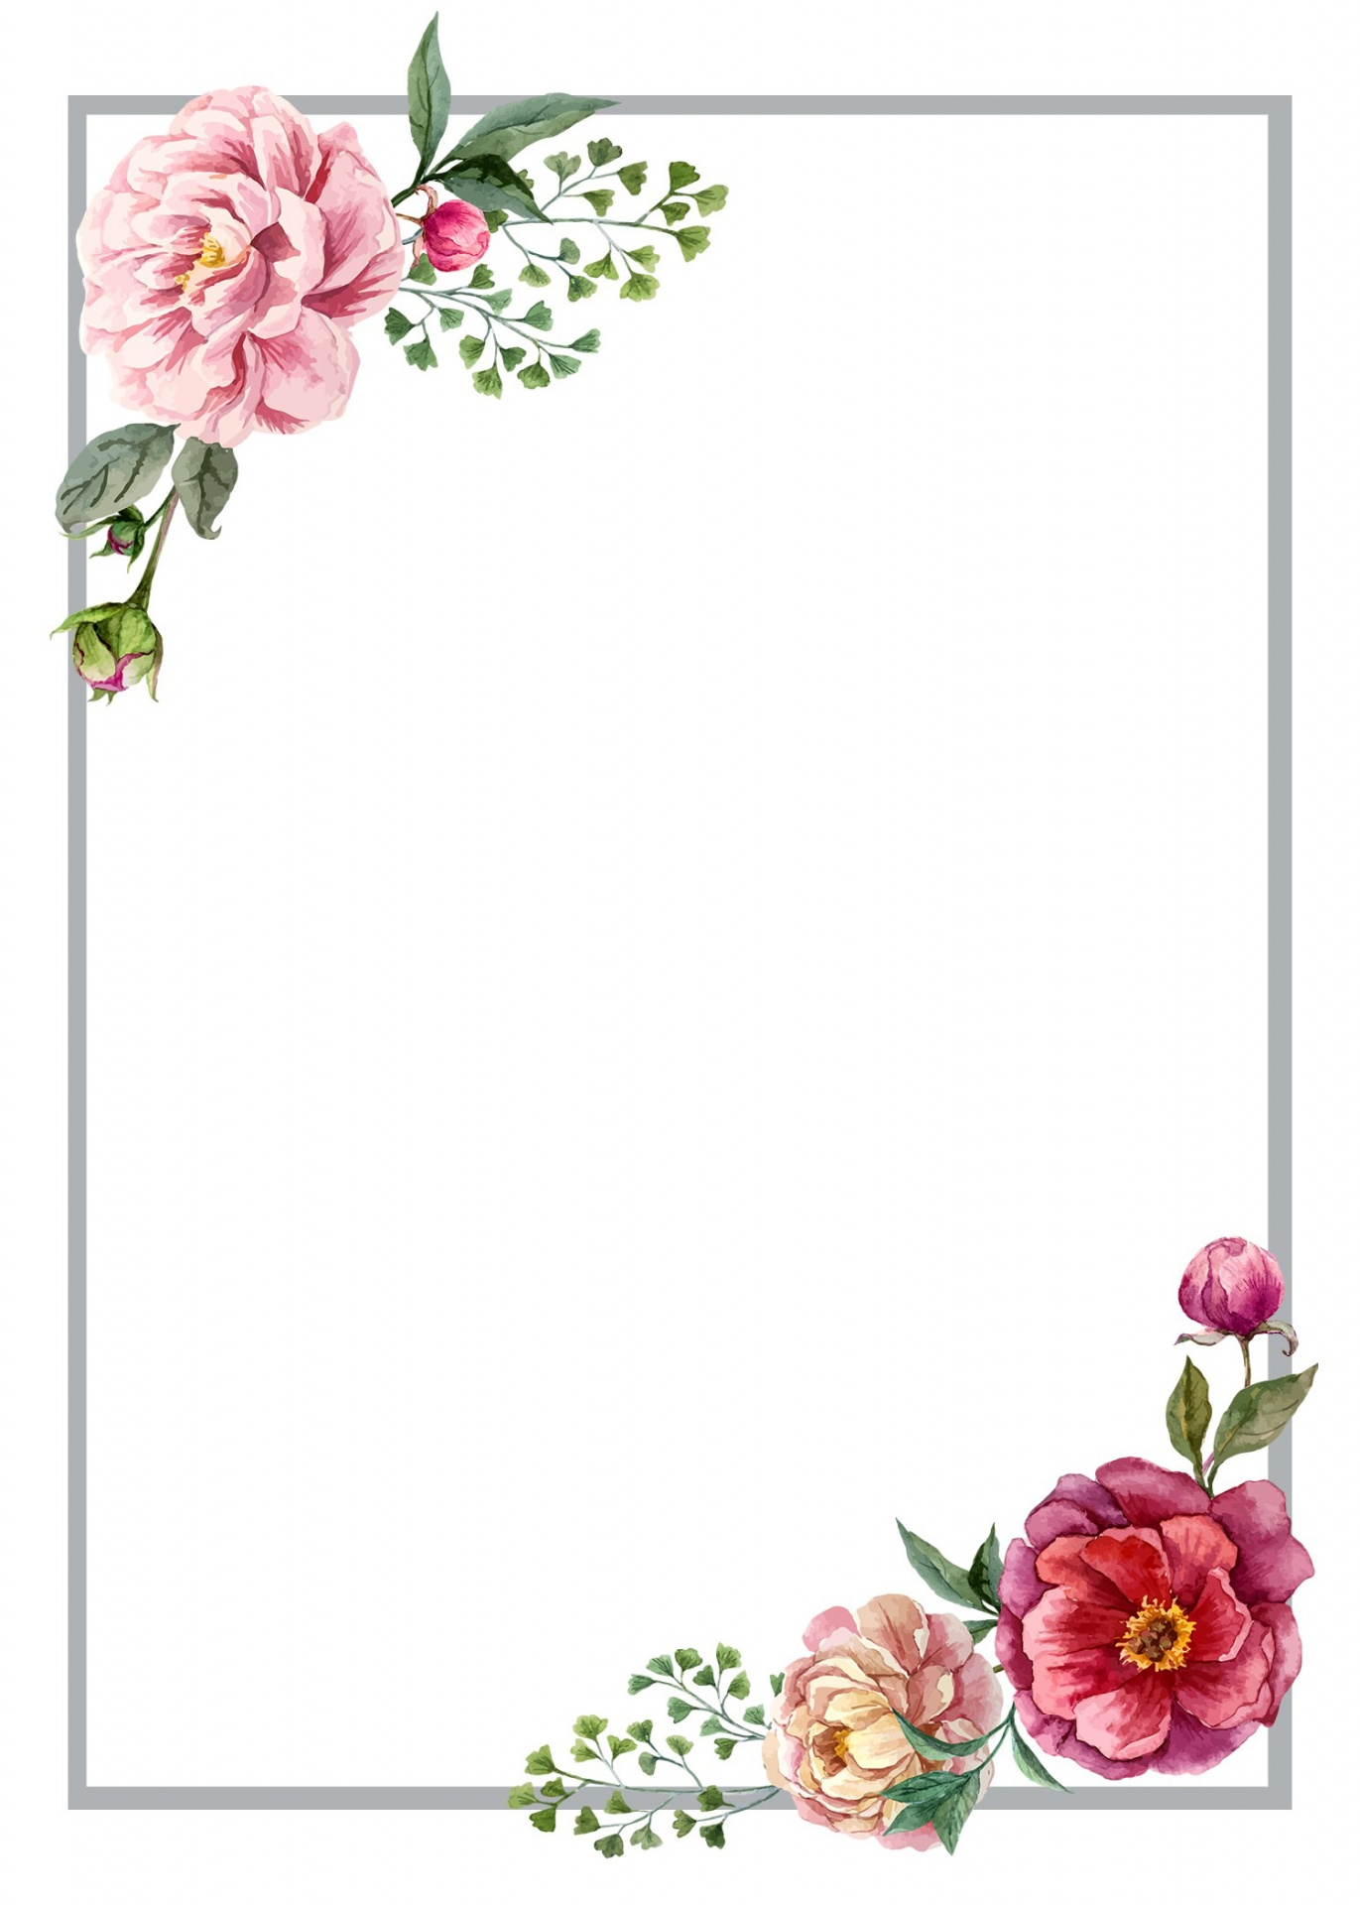

**JOIN US TO CELEBRATE**

JAHID’S

BIRTHDAY

SUNDAY SEPTEMBER 1ST

AT 9PM O CLOCK | MASTER’S HOUSE

ADDRESS

DUWARA BAZAR, SUNAMGONJ